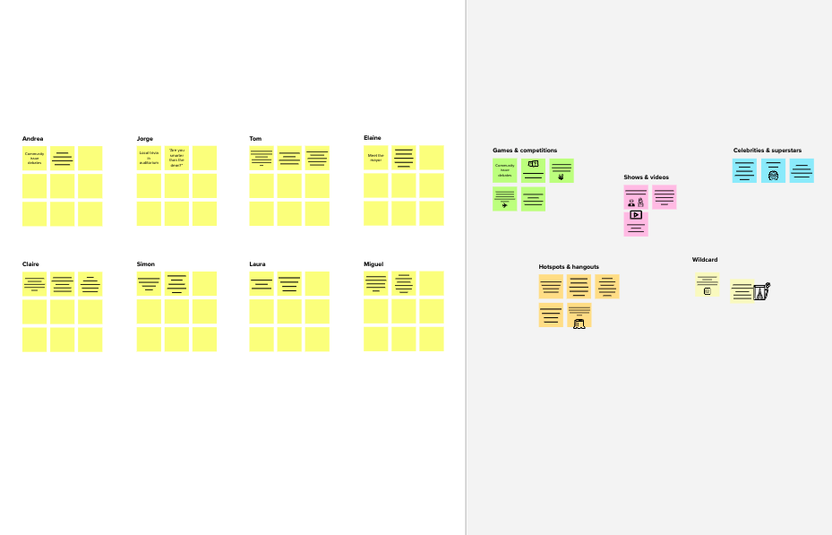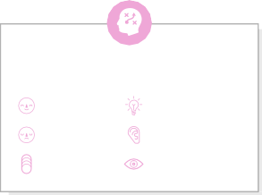

# Brainstorm

### Before you collaborate

A little bit of preparation goes a long way with this session. Here’s what you need to do to get going.

**10 minutes**

### Define your problem statement

Chronic kidney disease (CKD) is a life-threatening condition that can be difficult to diagnose early because there are no symptoms. The purpose of the proposed study is to develop and validate a predictive model for the prediction of chronic kidney disease.

**PROBLEM**

**Chronic kidney disease (CKD) is a life-threatening condition that can be difficult to diagnose early because there are no symptoms. To avoid these cases, CKD should be predicted earlier by ML algorithms.**

### 2

**Brainstorm**

Chronic kidney disease, also called chronic kidney failure, describes the gradual loss of kidney function. Chronic kidney disease can progress to end-stage kidney failure, which is fatal without artificial filtering (dialysis) or a kidney transplant. To avoid these conditions, early prediction of chronic kidney disease helps the most to find the disease earlier and can make it curable.

**10 minutes**

ARUNITHA VR GAYATHRI G SWETHA E VAISHNAVI S



SWETHA E VAISHNAVI S

Kidney disease is often caused by diabetes and high blood pressure

The purpose of this model is to develop and validate predictive models for CKD

Create awareness among the people

### 3

**Group ideas**

Take turns sharing your ideas while clustering similar or related notes as you go. In the last 10 minutes, give each cluster a sentence-like label. If a cluster is bigger than six sticky notes, try and see if you and break it up into smaller sub-groups.

**20 minutes**

It is easy to access because it is a web based application so it is intractable.

The main advantage is there is no need for kidney transplant

Detection of chronic kidney disease by using ml techniques

The prevention is drink essential water for a day

### 4

**Prioritize**

Your team should all be on the same page about what's important moving forward. Place your ideas on this grid to determine which are important and feasible.

**20 minutes**

Should go for regular checkup

### After you collaborate

You can export the mural as an image or pdf to share with members of your company who might find it helpful.

**Quick add-ons**

# & idea prioritization

**TIP**

## Brainstorming provides a free and open environment that encourages everyone within a team to partici-pate in the creative thinking process that leads to problem-solving.

1. **Team gathering**

Define who should participate in the session and send an invite. Share relevant information or pre-work ahead.

1. **Set the goal**

Think about the problem you'll be focusing on solving in the brainstorming session.

1. **Learn how to use the facilitation tools**

Use the Facilitation Superpowers to run a happy and

**ARUNITHA VR**

**How often it occurs?**

**GAYATHRI G**

Avoid kidney transplantati-on

**Yes the estimated value is 97% correct**

**Excited**

Yes the estimated value is 97%

Should consider a symptoms of ckd

It can be easily accessible for user

Many algorithms are feasible for predict ckd

#### People can take treatment earlier

It is a Intractable web based application which predict ckd

1. **Share the mural**

**Share a view link** to the mural with stakeholders to keep them in the loop about the outcomes of the session.

1. **Export the mural**

Export a copy of the mural as a PNG or PDF to attach to emails, include in slides or save in your drive.

Aim is to reduce ckd cases

**10 minutes** to prepare

**1 hour** to collaborate

**4 people** recommended

productive session.

BATCH NO: B6-6M2E

TITLE: Early Detection of Chronic Kidney Disease using Machine Learning

[**Open article**](https://support.mural.co/en/articles/2113740-facilitation-superpowers)

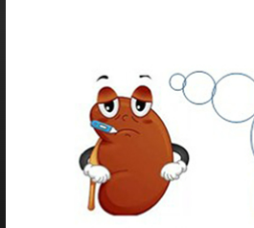

Go for regular check up

**SWETHA E**

**What's already in the market?**

**Is it used by**

Eat limited amount of sodium

**Drink lot of water to dilution of sodium**

**VAISHNAVI S**

**What must be achieved?**

Aged people may affect easily

A life-threatening condition that can be difficult to diagnose

**What did you gain?**

**What methodologies can help in**

Models also teach the patient how to live a healthy life

CKD can progress to end-stage kidney failure, which is fatal without artificial filtering (dialysis)

### Keep moving forward

**Strategy blueprint**

Define the components of a new idea or strategy.

[**Open the template**](https://app.mural.co/template/e95f612a-f72a-4772-bc48-545aaa04e0c9/984865a6-0a96-4472-a48d-47639307b3ca)

**Customer experience journey map**

Understand customer needs, motivations, and

tasks could get done without any difficulty or cost, which would have the most positive impact?

It is reliable with 97% accuracy.

**TIP**

**Strengths, weaknesses, opportunities & threats**

Identify strengths, weaknesses, opportunities, and threats (SWOT) to develop a plan.

|  |  |
| --- | --- |
|  |  |
|  |  |

[**Open the template**](https://app.mural.co/template/6a062671-89ee-4b76-9409-2603d8b098be/ca270343-1d54-4952-9d8c-fbc303ffd0f2)

[**Share template feedback**](https://muralco.typeform.com/to/CiqaHVat?typeform-source=app.mural.co)

Should many a healthy diet to avoid ckd

Should create aware about ckd

CKD does not have symptoms